**Project Report : Health Hub Medical Clinic**

**1. INTRODUCTION :**

Brief overview of the healthcare landscape in th region and the need for a multi specialty medical clinic .

**1.1.Objective** : To establish a emprehensive medical clinic offering a wide a range of healthcare services and wellness programmes to th community.

1. Establishment of a Modern Clinic: Design and construct a modern medical clinic equipped with advanced medical facilities and technology.

2. Provision of Comprehensive Medical Services: Provide a wide range of medical services including general consultations, specialized care, diagnostic services, and preventive health programs.

3. Community Engagement: Actively engage with the local community to understand their healthcare needs and preferences.

4. Staffing and Training: Recruit skilled healthcare professionals and provide ongoing training to ensure the highest standard of care.

5. Operational Efficiency: Implement efficient processes and systems to ensure smooth clinic operations and minimize waiting times for patients.

2. Problem definition & design thinking

2.1 Empathy Map

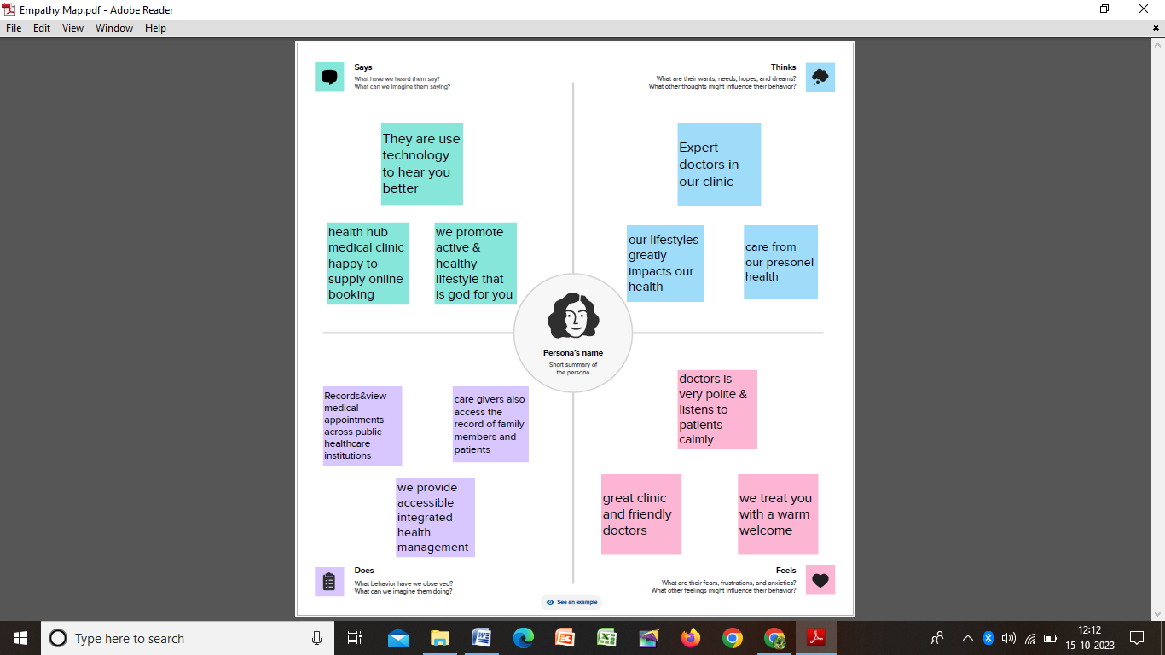

2.2 Ideation & Brainstorming map

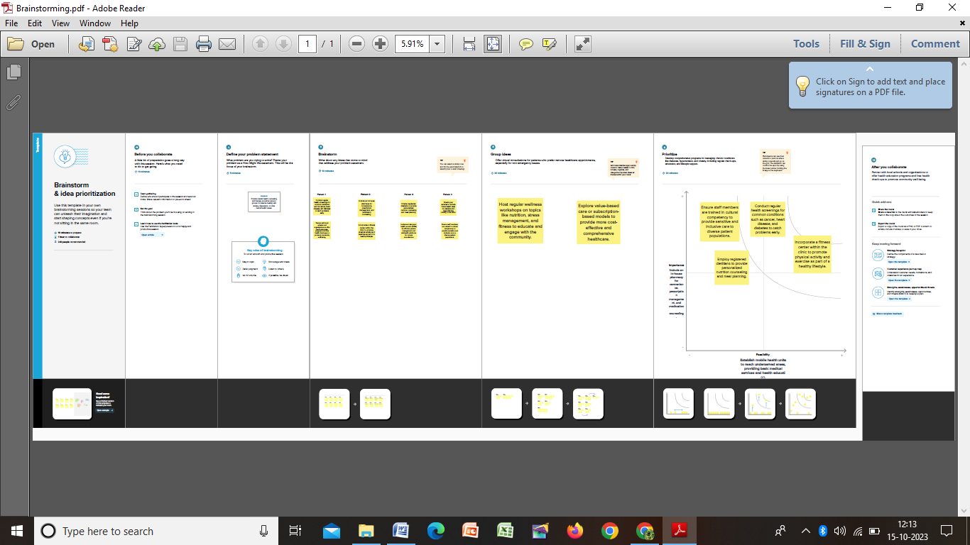

3.RESULT

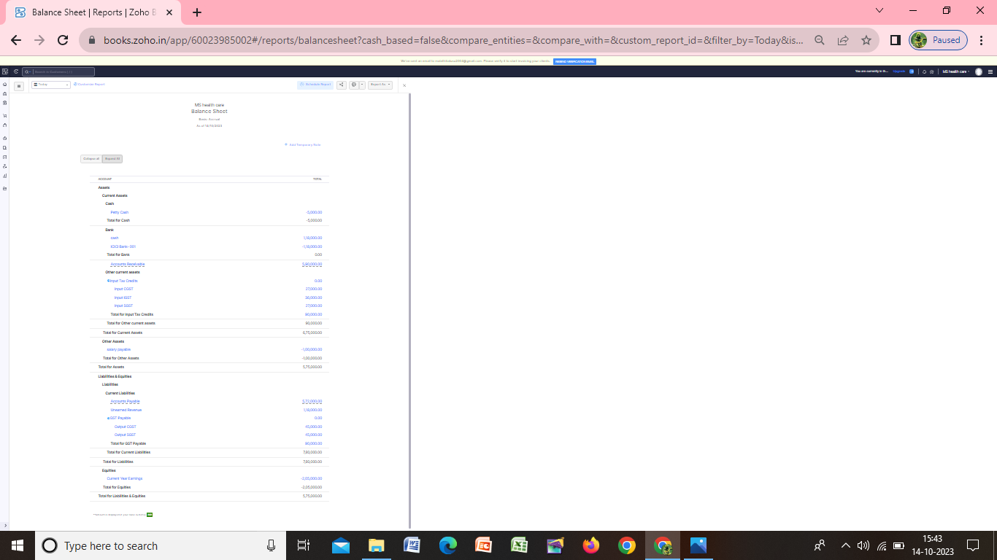

4.CHALLENGES FACED:

1. Regulatory Compliance: Navigating through various regulatory requirements and obtaining necessary licenses posed a significant challenge.

2. Supply Chain Delays: Delays in equipment procurement due to global supply chain disruptions impacted the project timeline.

3. Staffing and Training: Identifying and recruiting skilled healthcare professionals was a time-consuming process.

4. Pandemic-Related Considerations: The COVID-19 pandemic necessitated additional safety measures and protocols, affecting both construction and operations.

5.ADVANTAGES :

**Convenience**: Medical clinics are often strategically located in accessible areas, making it easier for patients to seek medical care without having to travel long distances.

**Timely Care:** Clinics often have shorter waiting times compared to hospitals for non-emergency conditions. They are more likely to offer same-day appointments.

**Cost-Efficient:** In many cases, clinics are less expensive than hospitals for routine and non-emergency care. They may also accept a wider range of insurance plans.

DISADVANTAGES :

**Limited Services:** Clinics may not offer the same range of services as a full-scale hospital. They might not have specialized equipment or specialists on staff.

**Emergency Care:** They may not be equipped to handle serious emergencies. In such cases, patients may need to be transferred to a hospital.

**Limited Hours:** Some clinics have limited operating hours compared to hospitals. This can be inconvenient for patients needing care outside of regular hours.

6. FUTURE SCOPE

Zoho development is going to focus on cloud service.

A Source code

https://github.com/sujamaa/health_hub_medial_clinic_